**[Project Name]**

**Business Process Specification**

|  |  |
| --- | --- |
| **Ngày** | [2012/03/20] |
| **Phiên bản** | [1.0.0.0] |
| **Trạng thái** | [Pending] |
| **Tác giả** | [Le Hoang Dinh Tuan, Developer] |
| **Duyệt bởi** | [Le Hoang Dinh Tuan, Project Manager] |
| **Ban hành bởi** | [] |

**Revision History**

| **Date** | **Version** | **Description** | **Author** |
| --- | --- | --- | --- |
|  |  | | |
| 2011/06/17 | 1.0.0.0 | Model business process | <Trinh Duc Tam> |
|  |  |  |  |
|  |  |  |  |
|  |  |  |  |

**Table of Content**

**Business Process Specification** 1

1 Introduction 4

1.1 Purpose 4

1.2 Scope 4

1.3 Definitions, Acronyms and Abbreviations 4

1.4 References 4

2 Business processes 4

2.1 Mô hình tổng thể 4

2.2 Outlet 5

2.2.1 Input Stock 5

# Introduction

## Purpose

Tài liệu mô tả mô hình nghiệp vụ của ứng dụng web ebookstore.

## Scope

This document is used by development team

## Definitions, Acronyms and Abbreviations

| **No.** | **Term** | **Description** |
| --- | --- | --- |
|  |  | |
|  |  |  |
|  |  |  |
|  |  |  |

## References

# Business processes

## Mô hình tổng thể

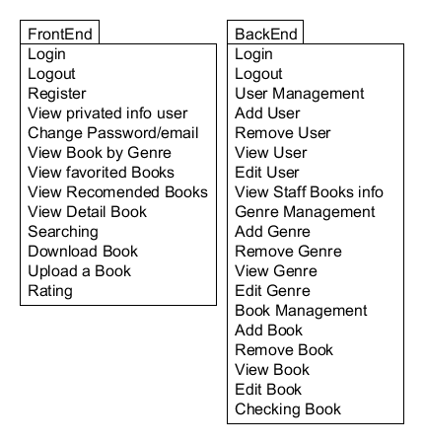

## FrontEnd

### View Book by Genre

#### Diagram

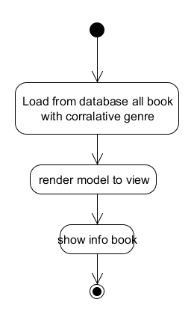

#### Activity

| **Act #** | **Activity Description** | **System/ Technology** | **Business Rules** | **Input or Output?** | **Functional Area - Role(s)** |
| --- | --- | --- | --- | --- | --- |
| 1 |  |  |  |  |  |
| 2 |  |  |  |  |  |
| 3 |  |  |  |  |  |
| 4 |  |  |  |  |  |
| 5 |  |  |  |  |  |

#### Business rules

| No | Rules | Description |
| --- | --- | --- |
|  |  | |
| R-001 |  |  |

### Download Book

#### Diagram

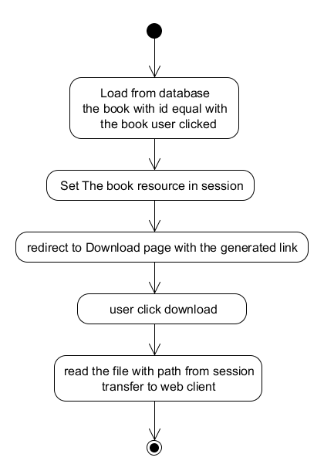

#### Activity

| **Act #** | **Activity Description** | **System/ Technology** | **Business Rules** | **Input or Output?** | **Functional Area - Role(s)** |
| --- | --- | --- | --- | --- | --- |
| 1 |  |  |  |  |  |
| 2 |  |  |  |  |  |
| 3 |  |  |  |  |  |
| 4 |  |  |  |  |  |
| 5 |  |  |  |  |  |

#### Business rules

| No | Rules | Description |
| --- | --- | --- |
|  |  | |
| R-001 |  |  |

### Rating

#### Diagram

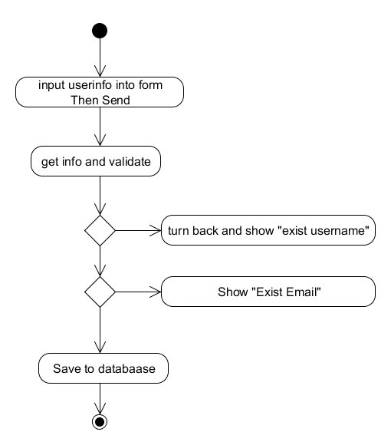

#### Activity

| **Act #** | **Activity Description** | **System/ Technology** | **Business Rules** | **Input or Output?** | **Functional Area - Role(s)** |
| --- | --- | --- | --- | --- | --- |
| 1 |  |  |  |  |  |
| 2 |  |  |  |  |  |
| 3 |  |  |  |  |  |
| 4 |  |  |  |  |  |
| 5 |  |  |  |  |  |

#### Business rules

| No | Rules | Description |
| --- | --- | --- |
|  |  | |
| R-001 |  |  |

## BackEnd

### Add user

#### Diagram



#### Activity

| **Act #** | **Activity Description** | **System/ Technology** | **Business Rules** | **Input or Output?** | **Functional Area - Role(s)** |
| --- | --- | --- | --- | --- | --- |
| 1 | Hệ thống tạo phiếu nhập kho |  | R-001 |  |  |
| 2 | Nhân viên tiến hành nhập kho |  |  |  |  |
| 3 | Hệ thống in phiếu nhập kho (Nếu cần) |  |  |  |  |
| 4 | Nhân viên nhận hàng ký tên |  |  |  |  |
| 5 | Bên giao hàng ký tên, quá trình nhập kho kết thúc |  |  |  |  |

#### Business rules

| No | Rules | Description |
| --- | --- | --- |
|  |  | |
| R-001 | Nhân viên phải đăng nhập để thực hiện chức năng này |  |